**INSTALL DOCKER CLI**

Welcome to Docker Desktop for Windows. This page contains information about Docker Desktop for Windows system requirements, download URL, instructions to install and update Docker Desktop for Windows.

**Download Docker Desktop for Windows**

[Docker Desktop for Windows](https://desktop.docker.com/win/main/amd64/Docker%20Desktop%20Installer.exe)

*For checksums, see*[*Release notes*](https://docs.docker.com/desktop/release-notes/)

**System requirements**

Your Windows machine must meet the following requirements to successfully install Docker Desktop.

* WSL 2 backend
* Hyper-V backend and Windows containers

**WSL 2 backend**

* Windows 11 64-bit: Home or Pro version 21H2 or higher, or Enterprise or Education version 21H2 or higher.
* Windows 10 64-bit: Home or Pro 21H1 (build 19043) or higher, or Enterprise or Education 20H2 (build 19042) or higher.
* Enable the WSL 2 feature on Windows. For detailed instructions, refer to the [Microsoft documentation](https://docs.microsoft.com/en-us/windows/wsl/install-win10).
* The following hardware prerequisites are required to successfully run WSL 2 on Windows 10 or Windows 11:
  + 64-bit processor with [Second Level Address Translation (SLAT)](https://en.wikipedia.org/wiki/Second_Level_Address_Translation)
  + 4GB system RAM
  + BIOS-level hardware virtualization support must be enabled in the BIOS settings. For more information, see [Virtualization](https://docs.docker.com/desktop/troubleshoot/topics/#virtualization).
* Download and install the [Linux kernel update package](https://docs.microsoft.com/windows/wsl/wsl2-kernel).

Docker only supports Docker Desktop on Windows for those versions of Windows 10 that are still within [Microsoft’s servicing timeline](https://support.microsoft.com/en-us/help/13853/windows-lifecycle-fact-sheet).

Containers and images created with Docker Desktop are shared between all user accounts on machines where it is installed. This is because all Windows accounts use the same VM to build and run containers. Note that it is not possible to share containers and images between user accounts when using the Docker Desktop WSL 2 backend.

Running Docker Desktop inside a VMware ESXi or Azure VM is supported for Docker Business customers. It requires enabling nested virtualization on the hypervisor first. For more information, see [Running Docker Desktop in a VM or VDI environment](https://docs.docker.com/desktop/vm-vdi/).

**About Windows containers**

Looking for information on using Windows containers?

* [Switch between Windows and Linux containers](https://docs.docker.com/desktop/faqs/windowsfaqs/#how-do-i-switch-between-windows-and-linux-containers) describes how you can toggle between Linux and Windows containers in Docker Desktop and points you to the tutorial mentioned above.
* [Getting Started with Windows Containers (Lab)](https://github.com/docker/labs/blob/master/windows/windows-containers/README.md) provides a tutorial on how to set up and run Windows containers on Windows 10, Windows Server 2016 and Windows Server 2019. It shows you how to use a MusicStore application with Windows containers.
* Docker Container Platform for Windows [articles and blog posts](https://www.docker.com/microsoft/) on the Docker website.

**Note**

To run Windows containers, you need Windows 10 or Windows 11 Professional or Enterprise edition. Windows Home or Education editions will only allow you to run Linux containers.

**Install Docker Desktop on Windows**

**Install interactively**

1. Double-click **Docker Desktop Installer.exe** to run the installer.

If you haven’t already downloaded the installer (Docker Desktop Installer.exe), you can get it from [**Docker Hub**](https://hub.docker.com/editions/community/docker-ce-desktop-windows/). It typically downloads to your Downloads folder, or you can run it from the recent downloads bar at the bottom of your web browser.

1. When prompted, ensure the **Use WSL 2 instead of Hyper-V** option on the Configuration page is selected or not depending on your choice of backend.

If your system only supports one of the two options, you will not be able to select which backend to use.

1. Follow the instructions on the installation wizard to authorize the installer and proceed with the install.
2. When the installation is successful, click **Close** to complete the installation process.
3. If your admin account is different to your user account, you must add the user to the **docker-users** group. Run **Computer Management** as an **administrator** and navigate to **Local Users and Groups** > **Groups** > **docker-users**. Right-click to add the user to the group. Log out and log back in for the changes to take effect.

**Install from the command line**

After downloading **Docker Desktop Installer.exe**, run the following command in a terminal to install Docker Desktop:

"Docker Desktop Installer.exe" install

If you’re using PowerShell you should run it as:

Start-Process 'Docker Desktop Installer.exe' -Wait install

If using the Windows Command Prompt:

start /w "" "Docker Desktop Installer.exe" install

The install command accepts the following flags:

* --quiet: suppresses information output when running the installer
* --accept-license: accepts the [Docker Subscription Service Agreement](https://www.docker.com/legal/docker-subscription-service-agreement) now, rather than requiring it to be accepted when the application is first run
* --no-windows-containers: disables Windows containers integration
* --allowed-org=<org name>: requires the user to sign in and be part of the specified Docker Hub organization when running the application
* --backend=<backend name>: selects the default backend to use for Docker Desktop, hyper-v, windows or wsl-2 (default)

If your admin account is different to your user account, you must add the user to the **docker-users** group:

net localgroup docker-users <user> /add

**Start Docker Desktop**

Docker Desktop does not start automatically after installation. To start Docker Desktop:

1. Search for Docker, and select **Docker Desktop** in the search results.

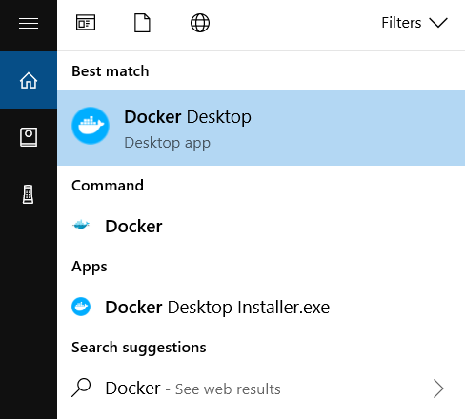

1. The Docker menu () displays the Docker Subscription Service Agreement window.

Here’s a summary of the key points:

* + Docker Desktop is free for small businesses (fewer than 250 employees AND less than $10 million in annual revenue), personal use, education, and non-commercial open source projects.
  + Otherwise, it requires a paid subscription for professional use.
  + Paid subscriptions are also required for government entities.
  + The Docker Pro, Team, and Business subscriptions include commercial use of Docker Desktop.

1. Select **Accept** to continue. Docker Desktop starts after you accept the terms.

**Important**

If you do not agree to the terms, the Docker Desktop application will close and you can no longer run Docker Desktop on your machine. You can choose to accept the terms at a later date by opening Docker Desktop.

For more information, see [Docker Desktop Subscription Service Agreement](https://www.docker.com/legal/docker-subscription-service-agreement/). We recommend that you also read the [FAQs](https://www.docker.com/pricing/faq).